Steel E-Motive Media Imagery and Captions

Image | Caption
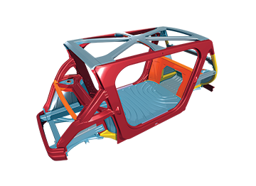 | File name: Steel_E-Motive_Body_Structure_three quarter side.png  Caption: Steel E-Motive’s B-Pillarless one-box open body structure provides a wider door aperture for easy ingress/egress, disability access, and cargo use.
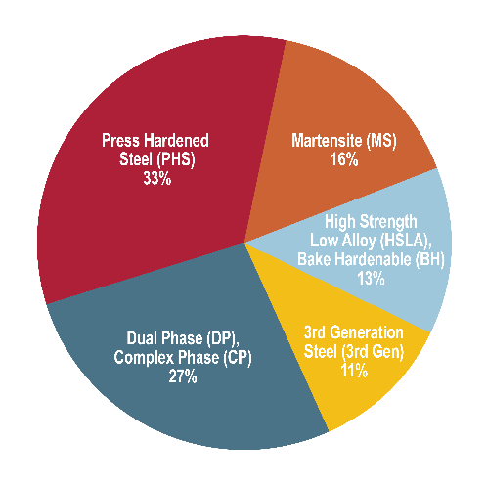 | File name: SEM Materials Distribution by Color ENG 3_31_23.jpg  Caption: Steel E-Motive Material Distribution Chart
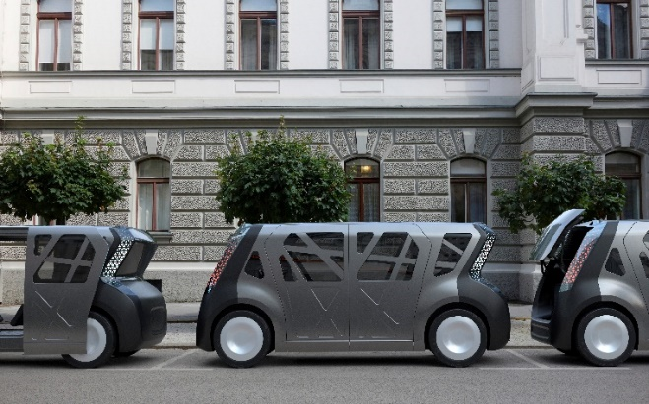 | File name: SEM Curbside 002.  Caption: Steel E-Motive is a fully autonomous ride sharing vehicle concept showcasing the strength and durability of steel with a critical focus on sustainability for reaching net zero emissions targets.

Image | Caption
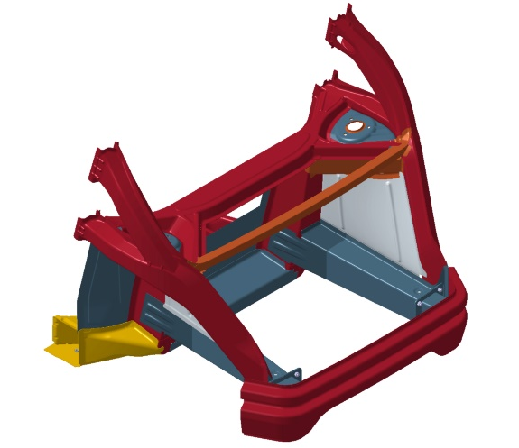 | File Name: SEM short front crash zone.jpg  Caption: The globally deployable Short Front Crash Zone structure meets the most stringent global crash requirements. Dual-Phase (DP) Tailor Welded Blanks enable efficient design. Press-hardened (PHS), Complex Phase (CP) and 3rd Gen AHSS help maintain a compact vehicle length.
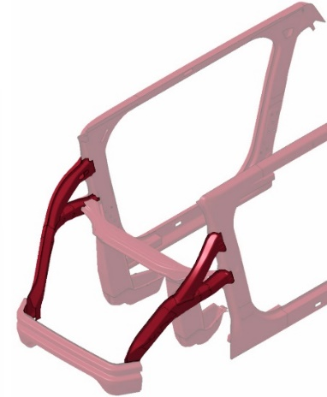 | File name: SEM glance beam.jpg  Caption: Small Offset Crash Glance Beam is an industry first, designed to minimize cabin intrusion and lower crash pulse, minimizing occupant injury.
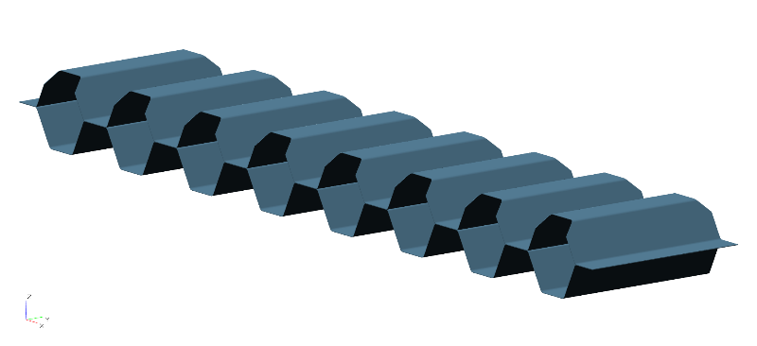 | File name: SEM_rocker-hex-absorber-beam.jpg  Caption: (Rocker) Hex beam energy absorbers are low cost, compact and mass efficient, minimizing side crash intrusion and achieving superior battery protection. Roll-formed Dual Phase steel provides superior energy absorption, manufacturing formability and cost efficiency.

Image |  | Caption
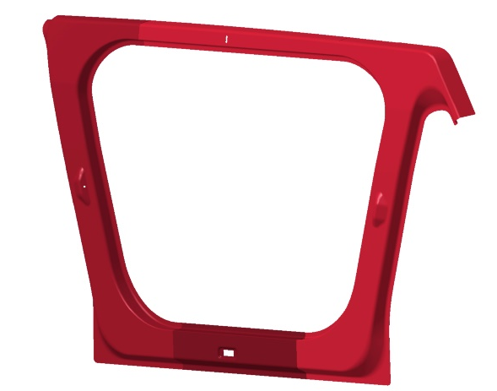 | File name: SEM door ring.jpg  Caption: A- and C-Pillar (door ring) uniquely aligns with the front occupant seating positions, enhancing protection. Removal of conventional bodyside outer panel provides significant mass and cost savings.  A four-zone tailor welded blank enables improved material utilization (scrap rate), and customized strength and mass where required.
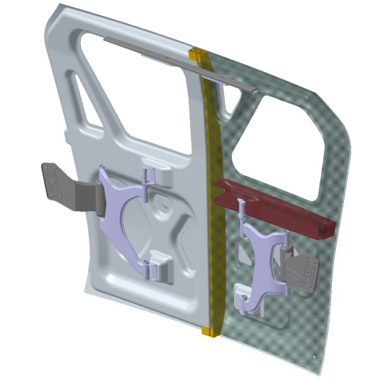 |  | File name: SEM virtual BPillar.jpg  Caption: Scissor Door with Virtual B-Pillars creates a compact section for better passenger visibility, improving passenger access and enabling better side crash performance. Bake Hardenable steel’s Class A-quality surface enables complete elimination of the body side outer for mass and cost savings.
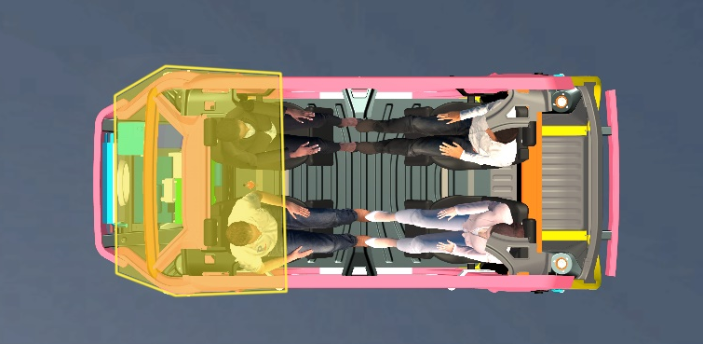 |  | File name: SEM AHSS extended passenger protection zone w people.jpg  Caption: The AHSS Extended Passenger Protection Zone provides excellent cabin intrusion protection and ultimately lower risk of injury. PHS provides formability for challenging geometries, which Martinsitic steel (MS) provides the strength to limit intrusion
File name: SEM Battery Carrier Frame.jpg

Caption: An Industry-first Battery Carrier Frame uses the existing floor as the top cover. It features an AHSS triple-skinned bottom cover that seals and protects the battery, resulting in 37% mass savings over benchmarks and 27% reduced cost.

